Satellite image classification

**Introduction:**

To detect the images received from satellites by using image processing which classifies objects and facilities in high-resolution multispectral satellite imagery. So we use image processing to make some enhancement on pictures to classify between the two classes. Our dataset consists of two classes in each class there is 1500 image, one class for cloudy and the other for green area.

**Related Work:**

Many literatures are devoted to satellite image segmentation and classification. They differ in many aspects such as, material images, used approach, or even the application limitations. The feasibility of using color features based classification method for satellite images is investigated in the following: in a novel method is presented for unsupervised classification in multi-temporal optical image based on feature extraction and K-Means clustering is proposed. After preprocessing the optical image is feature extracted using the discrete wavelet transform. The feature extracted image feature reduction is performed using energy based selection. Finally, different K means clustering is performed and analyzed using google colab and ground truth data for improving classification accuracy.

**Methodology:**

**Data:**

It was provided for the green area and cloudy classification of satellite images based on clustering. The implementation showed reasonable results. A segmentation and classification of remote sensing images were established; the classified image is given to k-Means algorithm. Our dataset consists of two classes in each class there is 1500 image so the total 3000 images, one class for cloudy and the other for green area with different dimensions



Figure 1: A sample image from the dataset of cloudy.

**Features:**

**Smoothing**: Blurring of the image to remove noise.

**Mean**: The mean is the total sum of all your numbers divided by the amount of numbers.

**The standard deviation**: To calculate the standard deviation, you subtract the mean from each value within the data set and square the answer.

**Histogram equalization** is a method in image processing of contrast adjustment using the image's histogram.

**Thresholding**: way to select areas of interest of an image, while ignoring the parts we are not concerned with.

**Entropy**: Discrete entropy is a measure of the number of bits required to encode image data. The higher the value of the entropy, the more detailed the image will be.

**Erosion**: is one of two fundamental operations (the other being dilation) in morphological image processing from which all other morphological operations are based.

**Canny edge:** is an edge detection operator that uses a multi-stage algorithm to detect a wide range of edges in images.

**Code:**

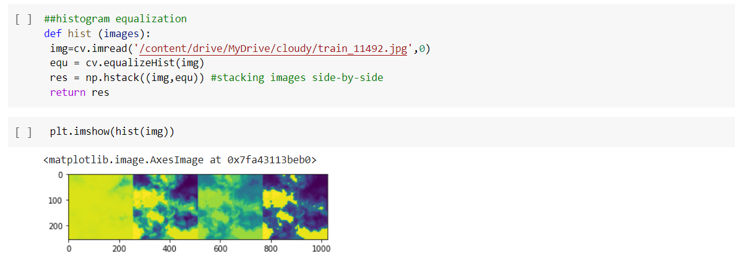

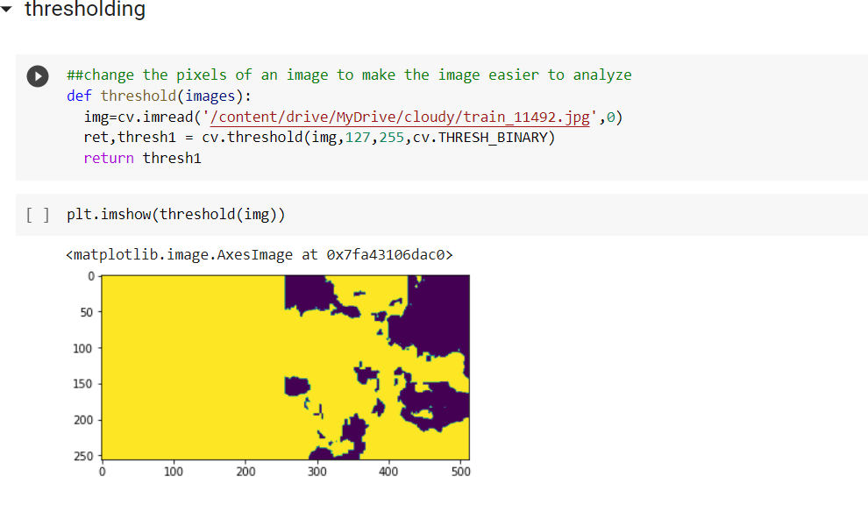

**Model:**

**The XGBoost model for classification** is called XGBClassifier. We can create and fit it to our training dataset. Models are fit using the scikit-learn API and the model fit() function. Parameters for training the model can be passed to the model in the constructor.

**Results:**

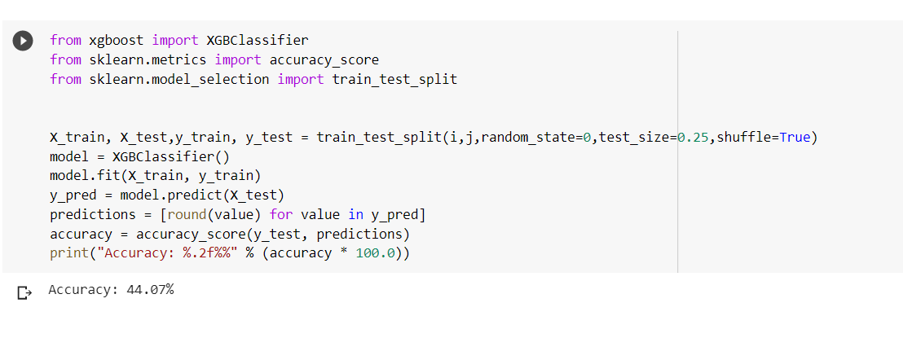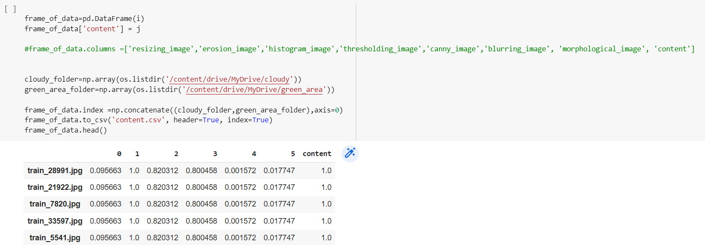

**Conclusion:**

Here here classify by mean and median and the result show in the frame

**References:**

[**https://www.academia.edu/37626561/Satellite_image_classification_and_feature_extraction_using_various_classification_techniques_A_survey**](https://www.academia.edu/37626561/Satellite_image_classification_and_feature_extraction_using_various_classification_techniques_A_survey)

[**https://www.irjet.net/archives/V9/i5/IRJET-V9I5402.pdf**](https://www.irjet.net/archives/V9/i5/IRJET-V9I5402.pdf)